IWRA Webinar :
How land matters for flood risk management

June 20th, 2018 at 13:00 (CET)

You are invited to join the next IWRA webinar on June 20th, 2018 at 13:00 (CET) (local time here)
Floods are one of the most significant hazards worldwide. Traditional measures against river floods provide limited protection. Measures to increase resilience and enhance flood retention are needed to complement traditional flood protection. Such measures usually claim more land than traditional measures. This land is already being used for other purposes and is often privately owned. This live stream event from the EU COST action LAND4FLOOD workshop “Towards an interdisciplinary understanding of (private) land for flood risk management” will be devoted to understanding the relationship of land and water.
Topics include:
- Land for Flood Risk Management - A catchment-wide and multi-level perspective
- Nature-Based Flood Risk Management on Private Land
- Policies and Instruments for Mobilising Private Land for Flood Risk Management
- Financial Schemes for Flood Recovery - Impact on Flood Resilience (Lenka Slavíková)

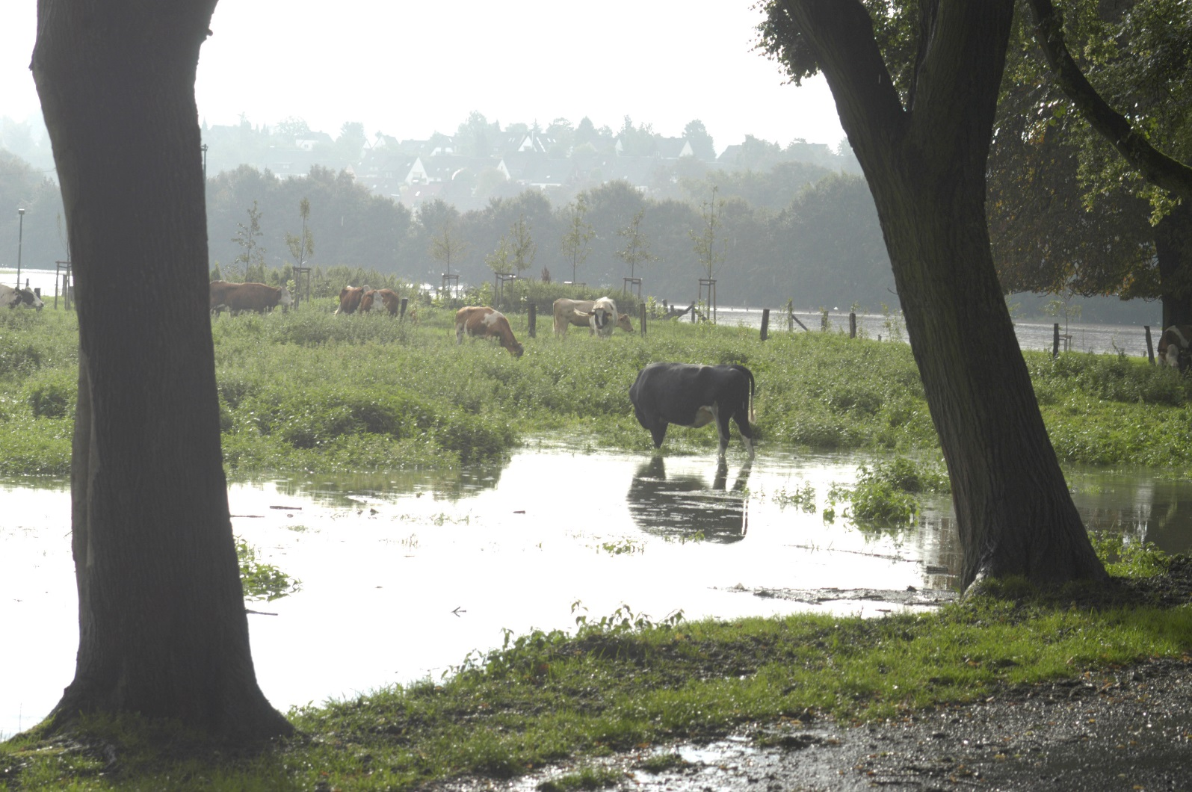
Panellists
- Thomas Hartmann (Wageningen University & Research)
- Jochen Schanze (TU Dresden & Leibniz Institute of Ecological Urban & Regional Development, Germany)
- Simon McCarthy (Flood Hazard Research Centre, Middlesex University, UK)
- Lukas Löschner (University of Natural Resources and Life Sciences, Vienna, Austria)
- Lenka Slavíková (Jan Evangelista Purkyně University, Ústí nad Labem, Czech Republik)

Moderator
Scott McKenzie, PhD Candidate, University of British Columbia

Participation
Participation is free and open to all. Audience questions are encouraged.
Register
https://attendee.gotowebinar.com/register/4086238598698876930

For more information and to browse past IWRA webinars: https://www.iwra.org/webinars/

IWRA Social media bubbles

